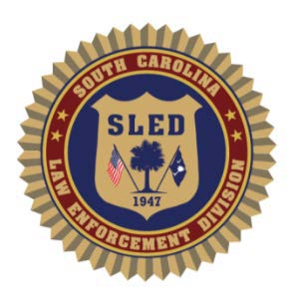
SC Law Enforcement Division
Forensic Services
iLab Access Request

Please select the applicable request(s)

 | NEW Account |  | Add to Investigating Officer Dropdown
 | UPDATED Account | Describe Update:

The following fields are required.
Name:
Title:
Email:*
Phone:
Agency/Employer
Region/Troop/NA
Address:
Supervisor:
Supervisor phone:
Supervisor email:*

Please select access type(s)

 | Prelog Cases |  | CODNA Check |  | View Case Information and Download Reports

*If you are requesting a user account and access to iLab, you must have an official law enforcement email address. iLab notifications and updates can only be sent to .gov, .mil, .us, or official email addresses.
Please feel free to contact the iLab support team at iLabrequests@sled.sc.gov with any questions or concerns.
Submit completed form to iLabrequests@sled.sc.gov

